EXTRA PROGRAMS :LAB 2

1

import java.util.*;

class player

{

String id,name;

int scores,no_matches_played;

player(String i,String n,int s,int no)

{

id=i;

name=n;

scores=s;

no_matches_played=no;

}

float cal()

{

float avg=(float)scores/(float)no_matches_played;

return(avg);

}

void display(float avg)

{

System.out.println("Id of player: "+id);

System.out.println("Name: "+name);

System.out.println("Scores: "+scores);

System.out.println("no of matches played: "+no_matches_played);

System.out.println("Average scores: "+avg);

}

public static void main(String args[])

{

Scanner sc=new Scanner(System.in);

System.out.println("enter player details");

System.out.println("enter id ");

String i=sc.nextLine();

System.out.println("enter name");

String n=sc.nextLine();

System.out.println("enter scores");

int s=sc.nextInt();

System.out.println("enter no of matches ");

int no1=sc.nextInt();

player ob1= new player(i,n,s,no1);

float play1=ob1.cal();

ob1.display(play1);

System.out.println("enter player details");

System.out.println("enter id ");

String ii=sc.nextLine();

System.out.println("enter name");

String nn=sc.nextLine();

System.out.println("enter scores");

int ss=sc.nextInt();

System.out.println("enter no of matches ");

int no2=sc.nextInt();

player ob2= new player(ii,nn,ss,no2);

float play2=ob2.cal();

ob2.display(play2);

if(play1>play2)

System.out.println("player 1 with average scores of "+play1+" has greater average scores than player 2");

else

System.out.println("player 2 with average scores of "+play2+" has greater average scores than player 1");

}

}

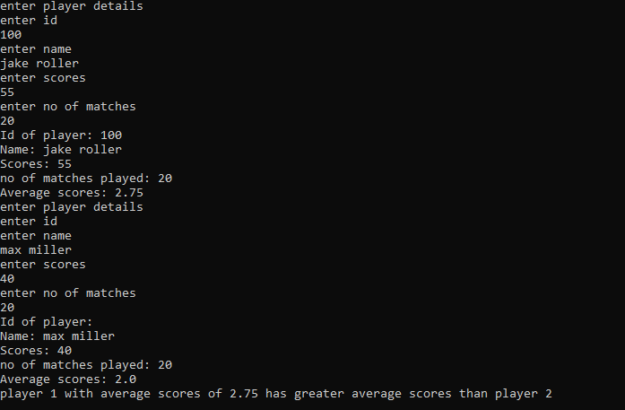

2

import java.util.*;

class book

{

String bookid,booktitle,author,publisher;

int no_of_page,year_of_pub,price;

void accept()

{

Scanner sc=new Scanner(System.in);

System.out.println("enter book id :");

bookid=sc.nextLine();

System.out.println("enter book title :");

booktitle=sc.nextLine();

System.out.println("enter author of the book :");

author=sc.nextLine();

System.out.println("enter publisher of the book :");

publisher=sc.nextLine();

System.out.println("enter no of pages of the book :");

no_of_page=sc.nextInt();

System.out.println("enter year of publish :");

year_of_pub=sc.nextInt();

System.out.println("enter price of book :");

price=sc.nextInt();

}

void display()

{

System.out.println("DETAILS OF BOOK :");

System.out.println("book id : "+bookid);

System.out.println("book title : "+booktitle);

System.out.println("author : "+author);

System.out.println("publisher : "+publisher);

System.out.println("no of pages : "+no_of_page);

System.out.println("year of publish : "+year_of_pub);

System.out.println("price of book : "+price);

}

static void expensive(int p1,int p2,int p3,String t1,String t2,String t3)

{

String exp="";

if((p1>p2)&&(p1>p3))

exp=t1;

else if(p2>p3)

exp=t2;

else

exp=t3;

System.out.println("most expensive book : "+exp);

}

static void count(int b1,int b2,int b3)

{

int c=0;

if(b1==2020)

c++;

if(b2==2020)

c++;

if(b3==2020)

c++;

System.out.println("no of books published in 2020 : "+c);

}

static void number(book o1,book o2,book o3)

{

book object=new book();

if((o1.no_of_page<o2.no_of_page)&&(o1.no_of_page<o3.no_of_page))

object=o1;

else if(o2.no_of_page<o3.no_of_page)

object= o2;

else

object=o3;

System.out.println("DETAILS OF BOOK WITH LEAST NO OF PAGES :");

System.out.println("book id : "+object.bookid);

System.out.println("book title : "+object.booktitle);

System.out.println("author : "+object.author);

System.out.println("publisher : "+object.publisher);

System.out.println("no of pages : "+object.no_of_page);

System.out.println("year of publish : "+object.year_of_pub);

System.out.println("price of book : "+object.price);

}

public static void main(String args[])

{

book obj1=new book();

book obj2=new book();

book obj3=new book();

System.out.println("BOOK 1:");

obj1.accept();

System.out.println("BOOK 2:");

obj2.accept();

System.out.println("BOOK 3:");

obj3.accept();

System.out.println("BOOK 1:");

obj1.display();

System.out.println("BOOK 2:");

obj2.display();

System.out.println("BOOK 3:");

obj3.display();

expensive(obj1.price,obj2.price,obj3.price,obj1.booktitle,obj2.booktitle,obj3.booktitle);

count(obj1.year_of_pub,obj2.year_of_pub,obj3.year_of_pub);

number(obj1,obj2,obj3);

}

}

